The Scope Of Fintech App Development And Why It Matters

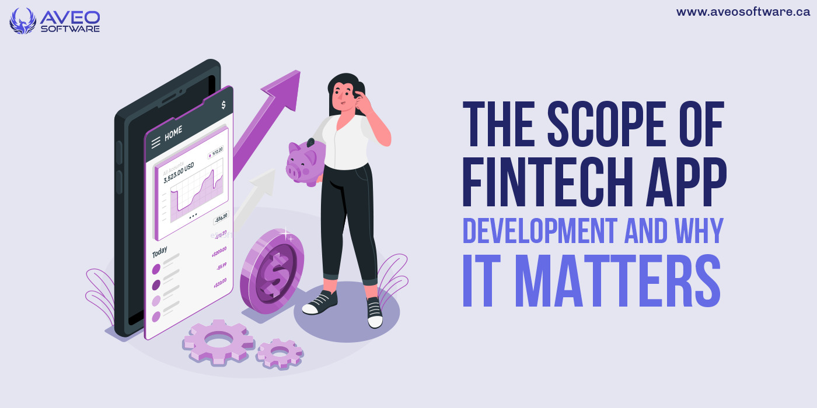

The phrase "fintech" is gaining popularity and is likely a buzzword that only a select group of tech-savvy individuals or knowledgeable business owners would understand.

Fintech, however, is neither a buzzword nor a concept you can't get familiar with if you stand back and look at it clearly. If you divide it into Finance and Technology, you'll be able to understand it even though it's probably not in your vocabulary yet.

Many people might not be entirely aware of the scope of Fintech app development. The good news is that you shouldn't worry if these topics are unclear to you. Today, we'll talk more about financial technology, developing Fintech applications, and related topics.

**What is Fintech?**

The word "fintech," which stands for [**"financial technology,**](https://href.li/?https://en.wikipedia.org/wiki/Financial_technology)**"** is used to describe the burgeoning sectors of the economy that employ technology to enhance the provision of financial services.

Fintech app development is thus the process of developing software programs that assist financial institutions in advancing the delivery of financial services by utilizing technology.

**Key areas of Fintech**

Recognizing the scope of Fintech app development requires first comprehending the primary sectors of the Fintech market. The foundation of businesses that develop Fintech apps is one of these sectors.

The following six topics are the foci of fintech applications:

* Insurance
* Investments
* Banking services
* Risk management
* Trading

This knowledge is essential because a Fintech app represents an entrepreneur's inventiveness in creating a software solution that addresses users' issues in these sectors.

Let's now get into the breadth of Fintech app development and the difficulties this sector is now facing.

So let's get going!

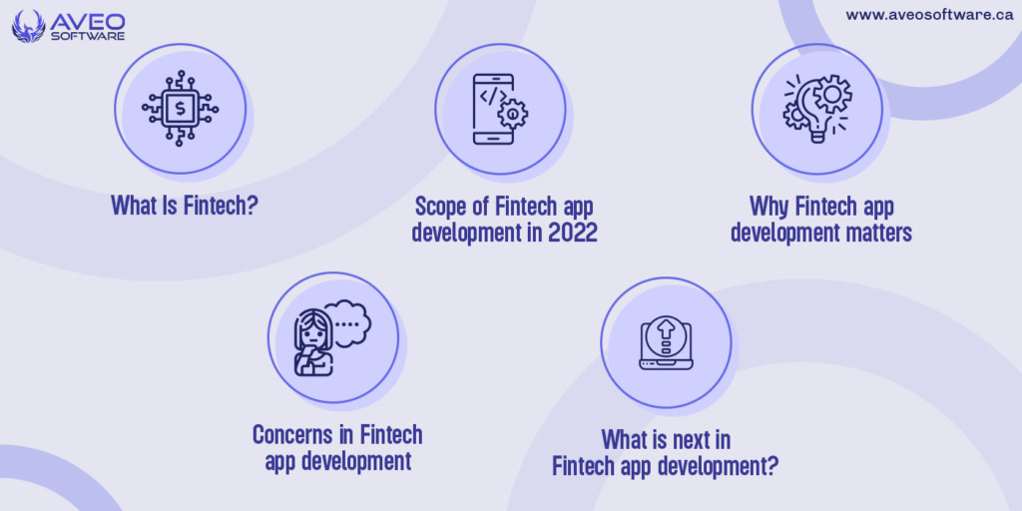

**Scope of Fintech app development in 2022**

The scope of fintech app development refers to how much financial services fintech applications provide for businesses looking to take use of technology.

FinTech is not a new industry, but it is a sizable one that influences the growth of many other industries. FinTech has had the biggest impact on industries including banking, payments, loans, insurance, savings, cryptocurrencies, and blockchain, for example.

Which financial services, though?

**Banking**

Through open banking, the banking industry is continuing to reshape innovation. Through [**Application Programming Interfaces (APIs)**](https://href.li/?https://www.infoworld.com/article/3269878/what-is-an-api-application-programming-interfaces-explained.html)**,** Open Banking enables third parties to access bank data, enabling banks or other financial organizations to offer financial services through their technological platforms.

When the banking industry focuses on [**data networks**](https://href.li/?https://www.heavy.ai/technical-glossary/data-network) rather than data centralization, innovation in fintech is conceivable. More clients can now safely access these "open data" for a variety of different financial services thanks to this breakthrough.

Numerous companies have seized this chance to create applications in order to better serve their customers by offering unique solutions as more and more [**banks continue to offer more open APIs**](https://href.li/?https://www.insiderintelligence.com/insights/open-banking-api-trends-explained/) for their services.

**Cryptocurrency**

The world of finance has been impacted by [**cryptocurrencies**.](https://href.li/?https://www.forbes.com/advisor/investing/cryptocurrency/what-is-cryptocurrency/) It offers a reduced chance of fraud, quicker transactions, and little middlemen's interventions in between transfers. It is now more appealing to businesses in the financial industry as a result.

Financial organizations of all sizes have embraced [**blockchain technology's**](https://href.li/?https://www.investopedia.com/terms/b/blockchain.asp) speed and security, opening up new chances to profit from the distributed ledger systems that underlie these digital currencies.

Although a wide range of businesses in the banking and FinTech industries have become more interested in cryptocurrencies, it's not just the technology that powers them.

Cryptocurrency isn't at the top of the list of [**Fintech app development trends**](https://href.li/?https://www.softermii.com/blog/fintech-app-development-top-tech-trends) right now, but it's climbing swiftly to get there. As a result, it is a strong technology with a lot of potential to revolutionize the sector.

**Insurance**

Insurance is frequently used to manage financial risk. All companies whose primary goal is to shield their clients from financial loss fall under the umbrella of the insurance industry.

Using technology to automate the purchase and usage of insurance policies to level the cost of risks and offer highly tailored plans and dynamically optimized premium pricing, insurtech is a subset of the fintech business.

The growth of insurtech app development reflects the perception that the sector is ready for innovation and disruption. This explains why there is [**more investment in the insurance industry.**](https://href.li/?https://www.oecd.org/investment/evolution-insurer-strategies-long-term-investing.pdf)

The majority of insurance operations are now faster because to automation experiments like the early adoption of[**Robotic Process Automation (RPA)**](https://href.li/?https://enterprisersproject.com/article/2019/5/rpa-robotic-process-automation-how-explain) in software development. However, the industry's fundamental operations and productivity have been completely transformed by the current application of AI and machine learning.

The creation of insurance-related apps is focused on employing modern technologies to enhance crucial decision-making procedures in underwriting, claims, pricing, and other relevant fields. Along with lowering costs and hastening the creation and delivery of insurance services, this technology will also improve the consumer experience.

**Funds Transfer**

Through peer-to-peer platforms, financial technology has simplified the process of sending money across borders between people or corporations. A quick and handy way to send money to anyone has been made possible by the emergence of fintech apps.

Even[**interbank transfers**](https://href.li/?https://www.lawinsider.com/dictionary/interbank-transfers) don't need to be done during specific hours because financial technology now makes it possible to conduct such transactions outside of banks even during off-hours. With the help of cutting-edge app development and mobile banking, users may now send money with just a few taps.

**Regulatory Technology**

A subgroup of the fintech sector called[**regulatory technology**](https://href.li/?https://www.ascentregtech.com/what-is-regtech/)gives more companies access to a safe and affordable way to deal with the growing [**regulatory reporting**](https://href.li/?https://www.pwc.com/us/en/industries/financial-services/regulatory-services/regulatory-reporting.html) requirements. Companies can monitor their data to comply with stringent regulatory standards thanks to regulatory reporting.

Companies are now looking towards technology to automate their data monitoring processes as they face penalties and fines for using ineffective regulatory reporting systems. Regtech, often known as regulatory technology, is the consequence of applying technology to monitor regulatory data.

There are more rising challenges for[**banks and other financial institutions**](https://href.li/?https://web.worldbank.org/archive/website01075/WEB/IMAGES/AML_IMPL.PDF) resulting from regulations against money laundering and terrorisms funding. So, it is an industry that many financial institutions look forward to creating beneficial applications that use AI/ML to respond to these demands in regulations.

**Why Fintech app development matters**

Technology has essentially taken over every business as it has spread to every part of the globe. Today, regardless of size, people respect all businesses equally, and technology will enable this equality.

Larger organizations that have not yet adopted or have little leverage on technology will be soon surpassed by small businesses with superior technology. The good news is that utilizing technology for your Fintech firm, from setup to expansion, is now more affordable.

People are now more likely to require a number of Fintech applications on their phones because to the spread of affordable yet powerful smartphones**.** [**Mobile app development**](https://href.li/?https://aveosoftware.ca/mobile-development/) is important along with the fact that individuals today anticipate being able to manage their funds conveniently.

Therefore, utilizing fintech in your organization is essential, and mobile applications are the simplest method to do it. Why? Because turning a device owned by thousands of your users is a cutting-edge commercial approach.

Additionally, Fintech is a terrific leveller for all sizes of businesses. Just a few years ago, huge enterprises in the sector were the only ones who could take advantage of the prospects that are now available to you.

**Concerns in Fintech app development**

The growth in the Fintech industry came with more serious concerns that are worth considering. These include security, costs, integrations, compliance, and user acquisitions. Let’s check them one by one:

**Data security**

The main problem in app development is cybersecurity. The rising fintech app risk has raised concerns among businesses that haven't yet fully embraced technology's capabilities.

Data security is a major concern for the Internet community as a whole. Data security in Fintech app development is more virtual, making it hard to apply previous solutions like more durable doors, security personnel, or CCTVs to protect the data.

Despite the seriousness of this issue, technical advancements have made it more difficult for thieves to obtain the data.

At[**Aveo Software**](https://href.li/?https://aveosoftware.ca/), data security is our priority. We have gathered enough expertise to establish a high level of security for all our Fintech app development. Whenever possible and reasonable, we will often consider the following and many other factors to secure your data:

* Biometric authentication
* Two-factor authorization
* Real-time alerts and notifications
* Data encryption and obfuscation

**Startup costs**

Cost is frequently the most important issue that many businesses take into account when developing a Fintech software application. The reason is that financing is a must to meet the expectations of your company and the market for app development.

Costs for software development can rise quickly if they are not carefully planned, organized, and studied. But if you do your research, you can increase your chances of[**picking the best software development firm.**](https://href.li/?https://aveosoftware.ca/7-factors-that-matter-when-evaluating-a-software-company-to-hire-in-canada/)

**Compliance with regulations**

Usually, it is impossible to avoid the government's scrutiny of the financial industry. While this may seem like a minor issue, if your software program violates the laws governing your sector, things will go horribly wrong.

Fortunately, it is simple to find legal consultants or specialists anywhere in the world that can assist you in understanding all the laws and rules governing the sector. Do your research to avoid creating anything that would be in conflict with the most recent legal guidelines issued by your government.

**What is next in Fintech app development?**

The future of Fintech apps has a lot of promise. Fintech will continue to grow, with developments including more embedded finance and pay-as-you-go eCommerce systems.

[**Fintech app development**](https://href.li/?https://aveosoftware.ca/mobile-development/) will continue to expand in line with the expanding Fintech industry's scope and demand. Therefore, as micro-industries continue to grow daily, app development expenses could increase.

Additionally, the number of Android users is increasing, and more Fintech businesses see it as being advantageous to develop apps for the millions of their users who currently use the platform. As a result, a business can use technology to provide its services at the convenience of its users, gaining access to a broad pool of people and improving user experience.